MEDIA KIT:
School-Related Sedentary Behaviour Recommendations for Children and Youth

Dear Sedentary Behaviour Research Network members and supporters,
The Sedentary Behaviour Research Network (SBRN) is proud to launch International School-Related Sedentary Behaviour Recommendations for Children and Youth through the International Journal of Behavioural Nutrition and Physical Activity.
The recommendations will assist stakeholders in education, health, research, and related sectors to implement actions and policies that support student health and wellbeing through managing school-related sedentary behaviours. They are available in English, French, Inuktitut and several other international languages.
Please assist by sharing the information in this media kit within your professional networks. This document provides some key information and sample communications to help you promote this important research.
We appreciate your support!
The SBRN Steering Group

Key Dates: Journal publication and media launch date: April 5, 2022
Links:
sedentarybehaviour.org/school-related-sedentary-behaviour-recommendations
https://phecanada.ca/activate/sedentary-behaviour
Social Media:
Follow @SedBehaviourRN on Twitter
Hashtag: #SedentaryBehaviour
Knowledge Products:
Resources for researchers and academics
Journal articles
Video
Resources for educators/administrators
Infographic
Blog (English)
Video
Shareable slide deck

Here’s how you can help:
- Retweet our messages on Twitter @SedBehaviourRN to encourage others to view the journal article and related knowledge products
Sample tweet for partner organizations:
The @SedBehaviourRN and [your organization’s name] have launched recommendations for improving student health and wellbeing through managing school-related sedentary behaviour. Learn more: https://www.sedentarybehaviour.org/school-related-sedentary-behaviour-recommendations/
Sample tweet for academic organizations:
The @SedBehaviourRN has launched recommendations for improving student health and wellbeing through managing school-related sedentary behaviour. Learn more: https://www.sedentarybehaviour.org/school-related-sedentary-behaviour-recommendations/
Sample tweets for education sector:
How can educators further support students’ health and wellbeing? Try replacing sedentary learning activities with movement-based activities, and reducing screen use in schools! Find out more at phecanada.ca/activate/reducingsedentarybehaviour @SedBehaviourRN
Want to learn what meaningful screen use is and how to encourage it in schools? Check out the newly launched @SedBehaviourRN recommendations on managing school-related sedentary behaviour: phecanada.ca/activate/reducingsedentarybehaviour @PHECanada
- Promote the recommendations within your schools and professional networks
You are invited to use the content below, or from our Blog (English or French), in your own emails or newsletters to help share the recommendations for school-related sedentary behaviour.
Sample Email
Dear Colleagues,
The Sedentary Behaviour Research Network (SBRN) recently launched International School-Related Sedentary Behaviour Recommendations for Children and Youth through the International Journal of Behavioural Nutrition and Physical Activity.
The recommendations will assist stakeholders in education, health, research, and related sectors to implement actions and policies that support student health and wellbeing through managing school-related sedentary behaviours. They are available in English, French, Inuktitut, and several international languages.
Visit the SBRN’s website for detailed recommendations or PHE Canada’s website for practical resources, such as journal articles, videos, blogs, infographics, a shareable slide deck and more!
You can also support student health and wellbeing through managing school-related sedentary behaviours by sharing this message with your networks, following @SedBehaviourRN on Twitter, or tweeting about this new resource using the hashtag #SedentaryBehaviour.
Sample Newsletter Content
Building More Opportunities for Movement into School-Related Activities
Educators and administrators know that getting students and staff moving more and minimizing screen use improves learning while supporting wellbeing. Yet research shows that a large portion of a student’s sedentary time happens in the classroom or during homework.
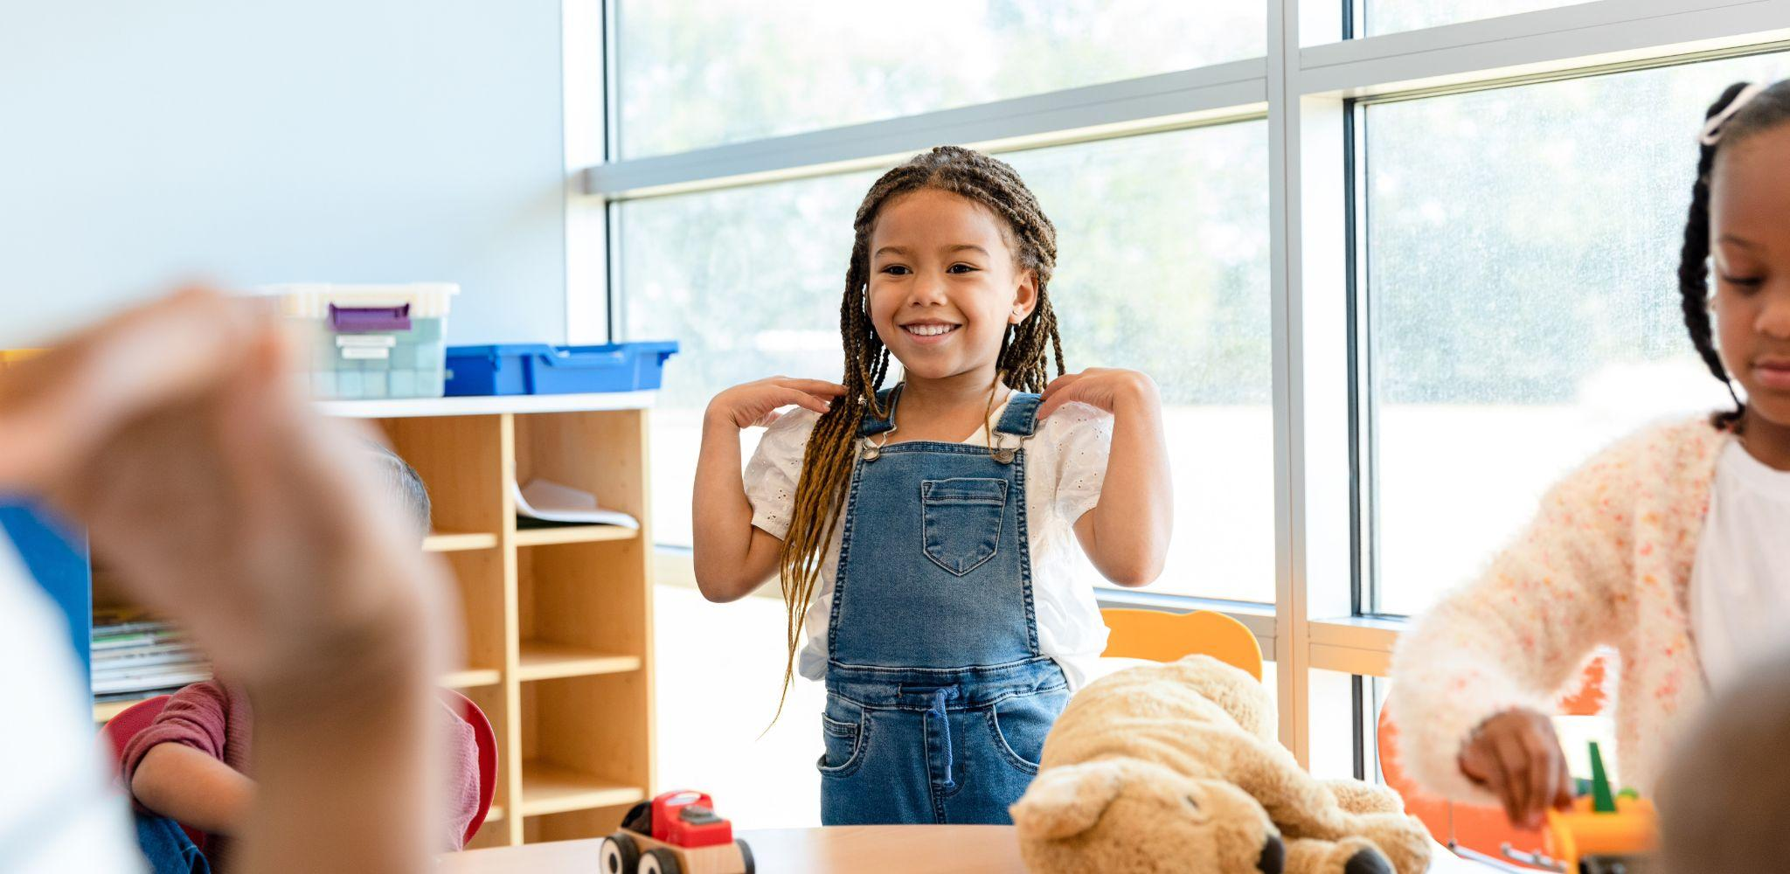
An international expert panel led by the Sedentary Behaviour Research Network has developed recommendations aimed at managing school-related sedentary behaviours and screen use. Visit their website to access the research, or visit PHE Canada’s website for tools to support educators and administrators in implementing the recommendations. 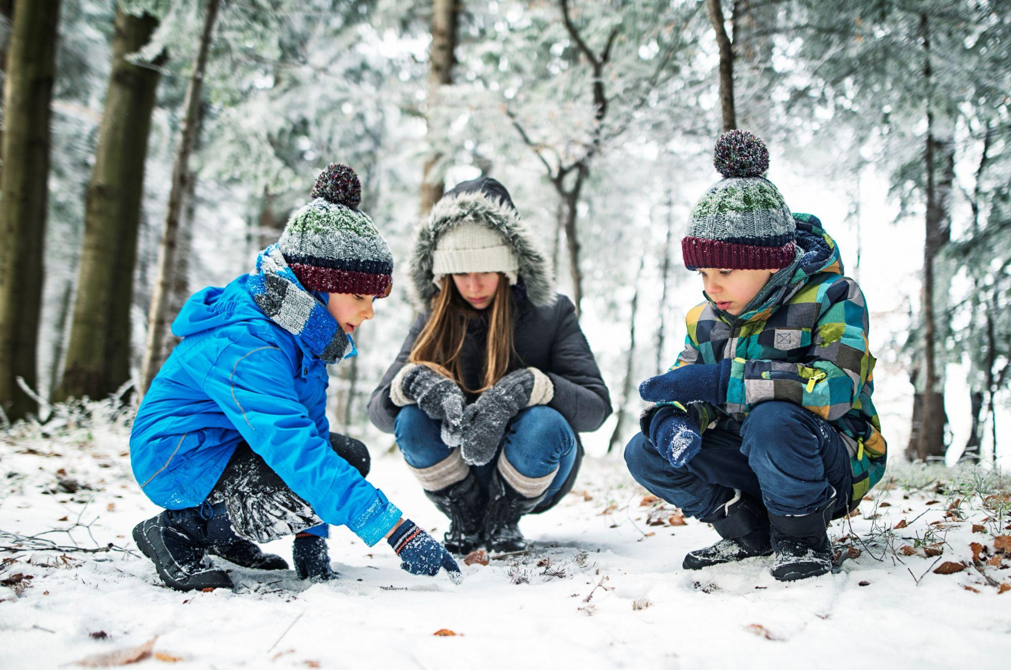

3.If your school/board is interested in evaluating their implementation of the recommendations, please let us know!
The SBRN is interested to know how the school-based sedentary behaviour recommendations are received; how they are implemented; and the benefits, costs, challenges and successes of implementation.
Contact Travis Saunders, University of Prince Edward Island, trsaunders@upei.ca with questions or comments.

